EX No:1 | EDA-Data Cleaning
Aim:

Algorithm:

Program:
import pandas as pd
df = pd.read_csv("realworld_medical_dirty.csv")
df = df.drop_duplicates()
for col in df.select_dtypes(include='object').columns:
df[col] = df[col].str.strip()
for col in df.select_dtypes(include='number').columns:
df[col] = df[col].fillna(df[col].mean())
for col in df.select_dtypes(include='object').columns:
df[col] = df[col].fillna(df[col].mode()[0])
print("\n===== Cleaned (Crisp) Dataset =====")
print(df)
print("\n===== First 10 Rows =====")
print(df.head(10))
print(df.info())
print(df.describe(include='all'))
import pandas as pd
from sklearn.model_selection import train_test_split
from sklearn.impute import SimpleImputer
from sklearn.preprocessing import LabelEncoder, StandardScaler
from sklearn.tree import DecisionTreeClassifier
from sklearn.metrics import accuracy_score
df = pd.read_csv("realworld_medical_dirty.csv")
print(df.head())
# KDD / SEMMA Steps
df = df.sample(frac=1, random_state=42)
print(df.info())
print(df.describe(include='all'))
for col in df.select_dtypes(include='number').columns:
df[col] = SimpleImputer(strategy='mean').fit_transform(df[[col]])

for col in df.select_dtypes(include='object').columns:
df[col] = SimpleImputer(strategy='most_frequent').fit_transform(df[[col]]).ravel()
encoder = LabelEncoder()
for col in df.select_dtypes(include='object').columns:
df[col] = encoder.fit_transform(df[col])
X = df.iloc[:, :-1]
y = df.iloc[:, -1]
scaler = StandardScaler()
X = scaler.fit_transform(X)
X_train, X_test, y_train, y_test = train_test_split(
X, y, test_size=0.2, random_state=42
)
model = DecisionTreeClassifier(random_state=42)
model.fit(X_train, y_train)
predictions = model.predict(X_test)
accuracy = accuracy_score(y_test, predictions)
print(f"Model Accuracy: {accuracy:.2%}")
Output:
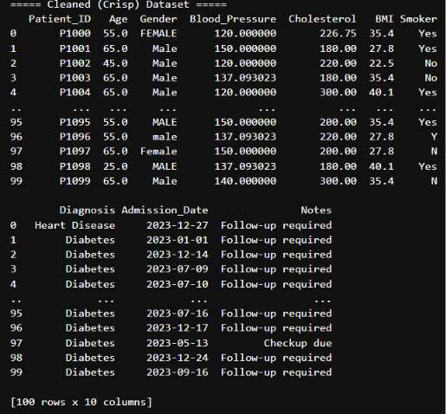

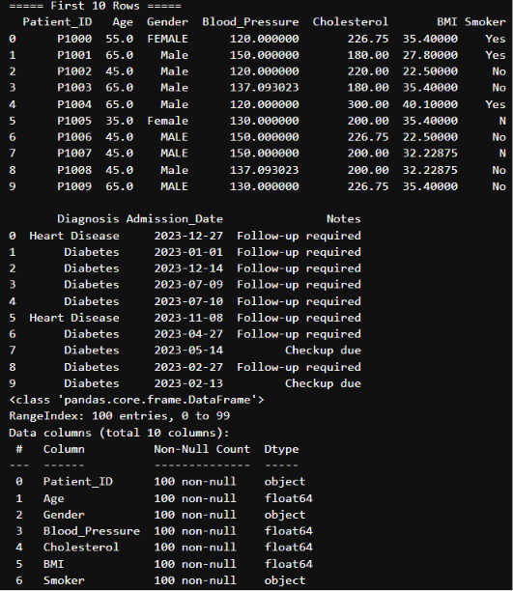
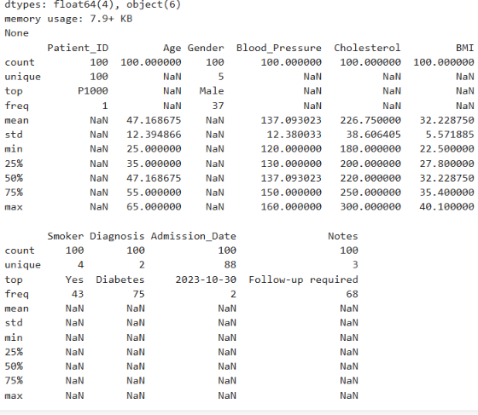
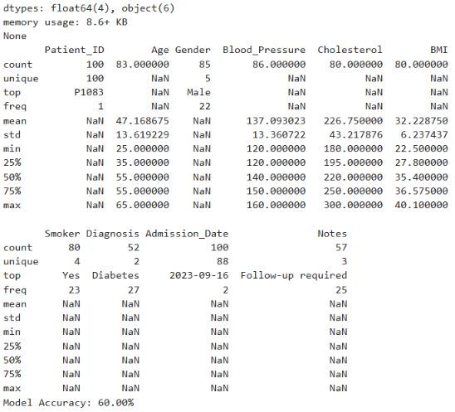

Result:

